**List of Some Resources**

This year, we will heavily rely on a cool board called ESP32. It is a development board with built-in WiFi and Bluetooth, so you can program it to connect to other devices (including your phone) via the internet to exchange data / control plethora of things. ESP32 is not Arduino, but it is programmed in a way similar to how you program an Arduino board; same IDE, same language (similar syntaxes), e.g. digitalWrite() on ESP32 works the same as it would on an Arduino, but not everything works the same, e.g. analogWrite() does not work on ESP32 (have to use another function).

You can refer to online resources. By no means this list is exhaustive. Some good resources are:

* Quick tutorial on RGB light (YouTube): <https://youtu.be/DkJ1f5UIuak>
* ESP32 guide: <https://randomnerdtutorials.com/getting-started-with-esp32/>
* Arduino language reference (contains explanation to what different functions do): <https://www.arduino.cc/reference/en/>
* Nice tutorials on Arduino (can be applied to ESP32) (YouTube): <https://www.youtube.com/user/OSHJunkies>
* What is Blynk? (YouTube): <https://www.youtube.com/watch?v=YULg0IoqoZM>
* Intro to Blynk (YouTube): <https://www.youtube.com/watch?v=3Yw4-u7JECg&list=PLFepjo7TI_AFu8UiU9y_FZM4JK8uA4Z54&index=2>
* Controlling LED via your phone:
  + <https://iotdesignpro.com/projects/iot-controlled-led-using-esp32-with-blynk-app>
  + <https://www.instructables.com/id/Use-ESP32-to-Control-LED-With-Blynk-Via-WiFi/>
* Blynk documentation (contains explanation for Blynk API / the functions Blynk provide): <https://docs.blynk.cc/>

You can also refer to the built-in example codes inside Arduino IDE; go to **File > Examples**, then pick the suitable topic. Example codes are also available for libraries (e.g. you can look up examples for FastLED or Blynk library to learn more about them).

**Example Codes Built-In Inside Arduino IDE**

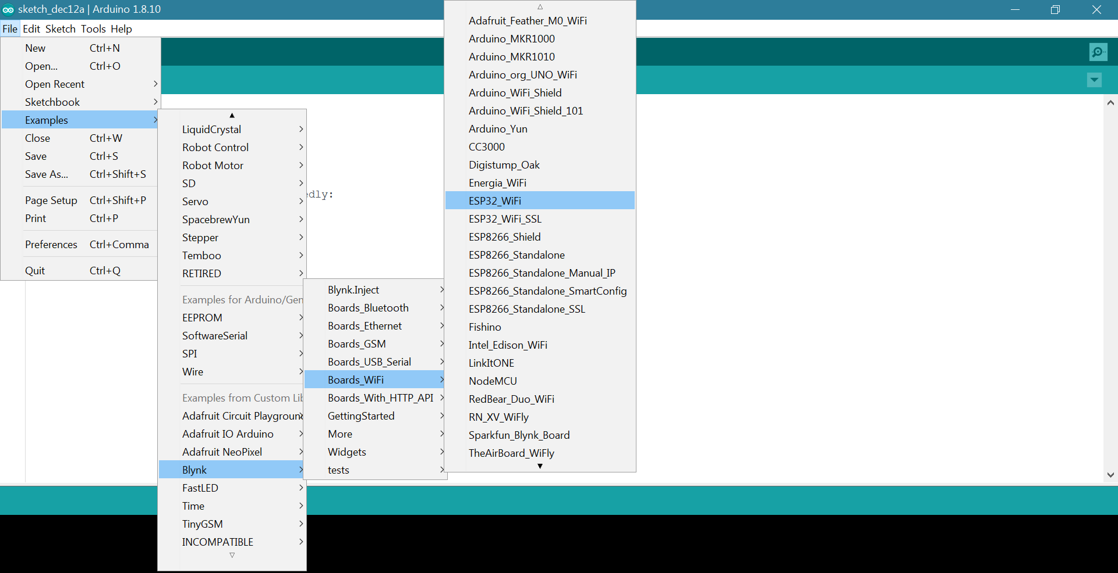

Finally, don’t forget that Google is your best friend. You can search for keywords like “ESP32 LED strip example”, or “ESP32 humidity sensor Blynk”, or even “Servo motor not working”; key in any problems you have.